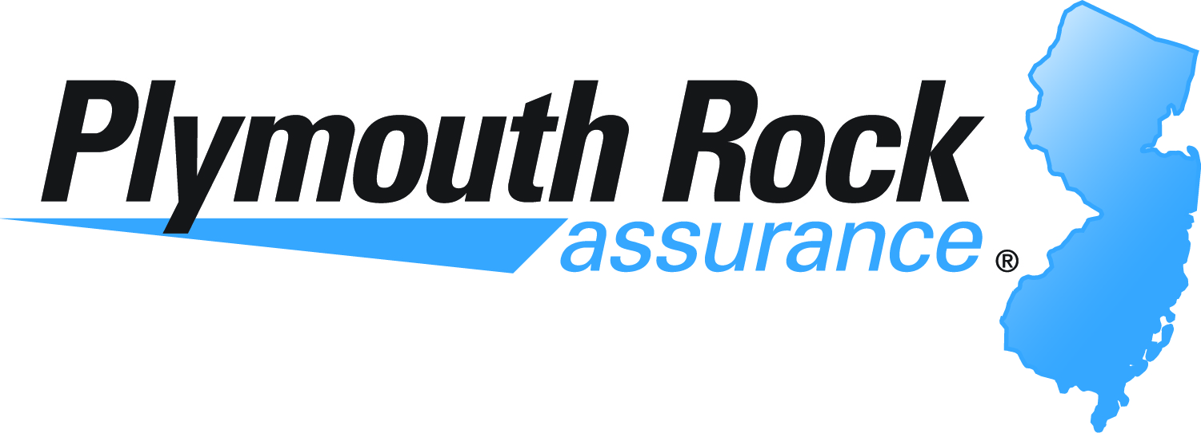

Direction Of Payment

Claim Number: Claim Rep:

Customer’s Name:

Vehicle Year and Make:

Referencing the above captioned claim, I (we) have received a complete copy of the itemized
repair estimate indicating all work to be performed and the costs.

Furthermore, I (we) authorize payment, on my behalf, directly to the repair shop, namely:

Bloomfield Auto Body Tax ID: 223-610-603

Customer’s Signature: _______________________________________________Date: _____________

I certify that the above captioned vehicle has been repaired to its pre-loss condition relative to safety, function and appearance, in accordance with the submitted repairs itemization.

GRP Shop Representative’s Signature: __________________________________Date: _____________

Original Estimate: ______________________________________
Supplement # 1: ______________________________________

Supplement #2: ______________________________________

Deductible: ______________________________________
Net Amount To be Paid By Plymouth Rock: ______________________________________

Any person who knowingly and with intent to defraud any insurance company or other person files an application for insurance containing any materially false information, or conceals for the purpose of misleading, information concerning any fact material thereto, and any person who knowingly makes or knowingly assists, abets, solicits or conspires with another to make a false report of theft, destruction, damage or conversion of any motor vehicle to a law enforcement agency, the department of motor vehicles or an insurance company, commits a fraudulent insurance act, which is a crime, and shall also be subject to a civil penalty not to exceed five thousand dollars and the value of the subject motor vehicle or stated claim for each violation.

